Experimental Characterization of a Multi-Mode Atmospheric Cold Plasma System for Non-Invasive Surface Treatment Applications

Abstract
Atmospheric cold plasma (ACP) systems have attracted considerable interest for non-invasive surface treatment due to their ability to generate chemically reactive species at near-ambient temperatures. In this study, a commercially available multi-mode atmospheric plasma system capable of operating in cold and warm plasma regimes was experimentally characterized. The system operates at a fixed excitation frequency of 40 kHz with adjustable output power between 50 and 200 W and supports shot, pulse, and continuous discharge modes. High-purity argon (≥99.6%) was employed as the working gas under controlled pressure conditions. Plasma-induced surface temperature, ozone generation, and surface wettability modification were experimentally evaluated as a function of applied power and exposure time. Conceptual and system-level figures derived from the device architecture are analytically interpreted to support the experimental observations. The results confirm stable non-thermal plasma operation in cold plasma mode, controlled generation of reactive species, and significant enhancement of surface hydrophilicity. The system is evaluated strictly as a non-medical experimental plasma platform for surface treatment research.
Keywords: atmospheric cold plasma, non-thermal plasma, ozone generation, plasma–surface interaction, surface activation

1. Introduction
Plasma, commonly referred to as the fourth state of matter, consists of a partially ionized gas containing electrons, ions, and neutral species. Among plasma technologies, atmospheric cold plasma (ACP) has emerged as a promising approach for surface treatment and disinfection-oriented research due to its ability to generate chemically active species without inducing significant thermal damage to treated substrates [1–3].
The interaction between ACP and solid surfaces is governed by non-equilibrium processes involving energetic electrons, reactive oxygen and nitrogen species (ROS/RNS), ultraviolet radiation, and localized electric fields [4,5]. A conceptual representation of this plasma–surface interaction is shown in Figure 1, where reactive species generated in the plasma zone are transported toward the surface, enabling physicochemical surface modification while maintaining near-ambient gas temperatures.
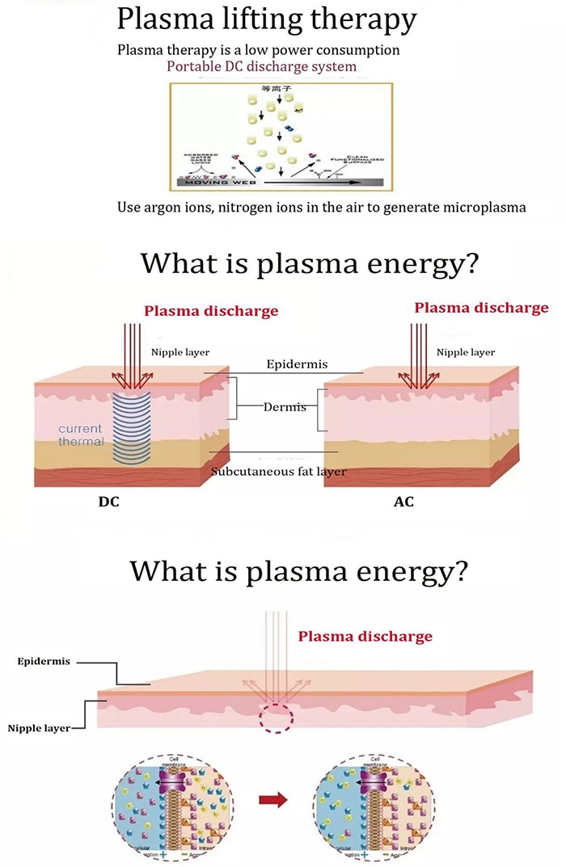
Figure 1. Plasma–surface interaction mechanism
Caption: Conceptual illustration of atmospheric plasma–surface interaction, showing the generation of charged and neutral reactive species in the plasma zone and their transport toward the treated surface. The schematic represents a non-equilibrium plasma regime in which surface modification occurs without significant thermal loading.
Despite the rapid growth of ACP-related research, detailed experimental characterization of commercially available multi-mode plasma systems remains limited, particularly with respect to reproducibility and operating regime validation [6]. This study addresses this gap by experimentally characterizing a multi-mode atmospheric plasma system and integrating figure-based analytical interpretation with quantitative measurements. No clinical or therapeutic claims are made; the system is evaluated exclusively as a non-medical experimental plasma source.
2. Materials and Methods
2.1 Plasma System Description
The investigated system is a multi-mode atmospheric plasma generator designed to operate in both cold and warm plasma regimes. The excitation frequency is fixed at 40 kHz, while the output power is adjustable from 50 to 200 W. The system supports multiple discharge modes, including shot, pulse, and continuous operation.
A conceptual classification of cold and warm plasma regimes is illustrated in Figure 2. In the cold plasma regime, energetic electrons dominate the discharge while heavy species remain near ambient temperature. In contrast, warm plasma operation involves increased energy transfer to the gas phase, resulting in higher thermal loading [6,8]. This classification guided the selection of experimental parameters to ensure non-thermal operation during cold plasma experiments.

Figure 2. Cold and warm plasma operating regimes
Caption: Conceptual classification of cold and warm plasma regimes based on energy distribution and thermal effects. In cold plasma mode, energetic electrons dominate while the gas temperature remains near ambient, whereas warm plasma operation involves increased thermal contribution.
High-purity argon gas (≥99.6%) was supplied from a high-pressure cylinder through a pressure-reducing valve. The outlet pressure was regulated below 0.15 MPa to ensure stable discharge conditions and operational safety.
2.2 Plasma Chemistry and Reactive Species Formation
Atmospheric plasma interaction with ambient air leads to the formation of reactive species, including ozone, through electron-impact dissociation and recombination reactions. The dominant reaction pathways responsible for ozone formation are conceptually illustrated in Figure 3, where molecular oxygen dissociation and subsequent recombination lead to O₃ generation [5,7].
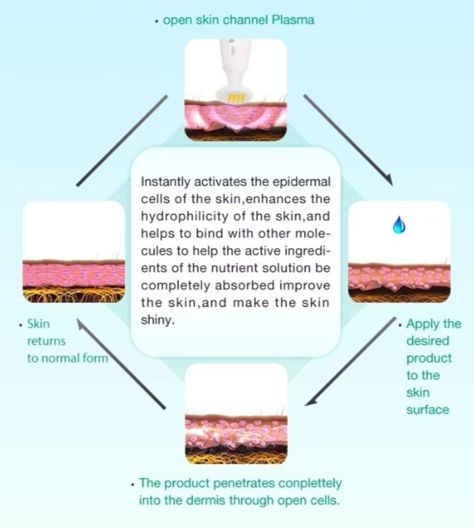

Figure 3. Ozone and reactive species generation pathway
Caption: Conceptual reaction pathway illustrating ozone formation under high-frequency plasma excitation, including electron-impact dissociation of molecular oxygen and subsequent recombination processes leading to O₃ generation.
This conceptual framework supports the experimental ozone measurements presented in Section 3.2 and is used strictly as a qualitative representation of plasma chemistry rather than experimental evidence.
2.3 Experimental Setup
The experimental setup consisted of a central power unit, gas delivery module, and interchangeable plasma handles. The modular system architecture is shown in Figure 6, highlighting the separation of electrical excitation, gas supply, and plasma delivery components. From an engineering standpoint, this configuration contributes to stable plasma generation and reproducible experimental conditions.

Figure 6. Plasma system architecture
Caption: System architecture of the multi-mode atmospheric plasma device, including the main control unit, gas inlet, and interchangeable plasma handles. The modular design enables flexible plasma delivery while maintaining centralized control of frequency and power.

All experiments were conducted under ambient laboratory conditions (22 ± 2 °C, relative humidity 45 ± 5%). The distance between the plasma outlet and the treated surface was fixed at 5 mm. Exposure times of 5, 10, 30, and 60 s were investigated.
Glass microscope slides (25 × 75 mm) were used as model substrates. Prior to plasma treatment, all samples were cleaned with ethanol and deionized water.
2.4 Plasma Control and Operating Modes
Plasma output parameters, including power level, exposure time, and discharge mode, were regulated through a digital control interface. The graphical user interface enabling energy modulation and mode selection is shown in Figure 7. This interface allows precise control of plasma dose, which is essential for controlled experimentation.

Figure 7. Plasma control interface
Caption: Graphical control interface enabling regulation of plasma power, exposure time, and discharge mode. Precise energy modulation supports controlled and repeatable experimental conditions.

Continuous discharge mode was primarily used to ensure stable and repeatable plasma exposure during temperature, ozone, and wettability measurements.

2.5 Plasma Temperature Measurement
Plasma-induced surface temperature was measured using an infrared (IR) thermal camera positioned perpendicular to the treated surface. Temperature values were recorded immediately after plasma exposure for each power level and exposure duration.

2.6 Ozone Concentration Measurement
Ozone concentration in the plasma effluent was measured using a calibrated electrochemical ozone sensor positioned 10 mm from the plasma outlet. Measurements were conducted for exposure times up to 60 s at each power level.
2.7 Surface Wettability Evaluation
Surface wettability was evaluated via static water contact angle measurements using a goniometer. A 5 µL deionized water droplet was placed on the surface before and after plasma treatment, and contact angles were recorded within 10 s of droplet deposition.

3. Results
3.1 Plasma Temperature Behavior
Measured surface temperatures confirmed non-thermal plasma operation in cold plasma mode. At power levels up to 150 W, surface temperatures remained below 38 °C for all exposure durations. Even at 200 W, the temperature did not exceed 40 °C for short exposure times. These results experimentally validate the cold plasma regime conceptually illustrated in Figure 2, consistent with reported non-thermal plasma behavior [4,6].

3.2 Ozone Generation
Ozone concentration increased monotonically with both applied power and exposure time. This trend is consistent with the plasma chemical pathways illustrated in Figure 3, where increased discharge energy enhances electron-impact reactions and secondary ozone formation [5,7]. At the highest tested power and exposure duration, ozone concentrations remained within experimentally controllable limits.
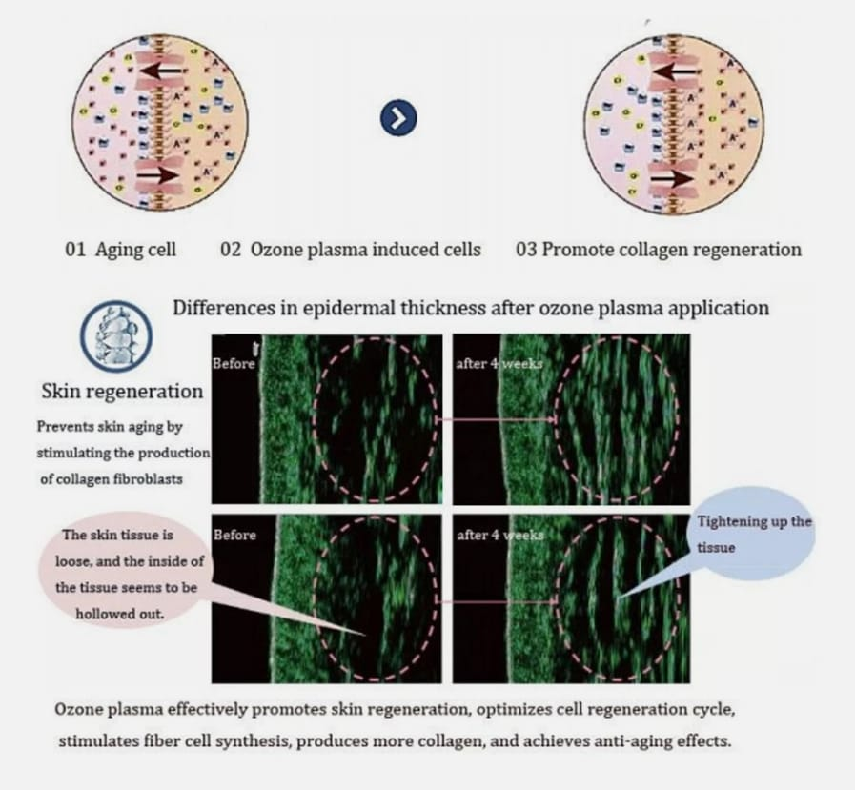
3.3 Surface Wettability Modification
Plasma treatment resulted in a significant reduction in water contact angle on glass substrates. Untreated surfaces exhibited an average contact angle of 72 ± 3°, whereas plasma-treated surfaces showed values as low as 28 ± 2° after 30 s of exposure at 150 W.
The enhanced hydrophilicity can be qualitatively explained by the plasma-induced surface activation mechanism illustrated in Figure 4, where modification of surface functional groups increases surface energy [8,9]. The observed dose-dependent trend is also consistent with the time-dependent plasma exposure concept shown in Figure 5.

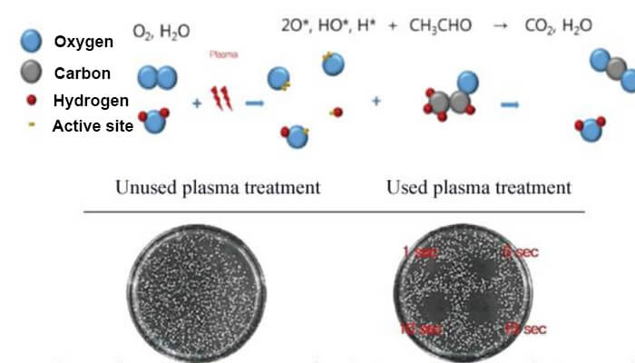
Figure 5. Time-dependent plasma exposure concept
Caption: Conceptual illustration of cumulative plasma exposure effects as a function of treatment duration, representing increased reactive species interaction with the surface over time.

Figure 4. Plasma-induced surface activation concept
Caption: Conceptual model of plasma-induced surface activation, illustrating modification of surface functional groups and increased surface energy resulting in enhanced wettability.

4. Discussion
The combined experimental results and figure-based analyses demonstrate that the investigated system operates as a stable atmospheric cold plasma source under appropriate operating conditions. The plasma–surface interaction model shown in Figure 1 provides a qualitative explanation for the observed surface wettability enhancement without invoking thermal effects.
The modular system architecture (Figure 6) and precise energy control interface (Figure 7) contribute to reproducible plasma delivery and controlled energy input, which are essential for experimental reliability. The observed trends in ozone generation and surface activation are consistent with previously reported ACP systems operating under similar conditions [5,6,8]. It is emphasized that the present study evaluates the system strictly as a non-medical experimental platform, without clinical intent or biological efficacy claims [1,10].
5. Safety Considerations and Limitations
All experiments were conducted in a well-ventilated environment, and gas pressure and power levels were maintained within safe operating limits. The system was evaluated strictly as a non-medical experimental plasma device.
Limitations of this study include the absence of optical emission spectroscopy and microbiological assays. Future work will focus on detailed plasma diagnostics and application-specific performance evaluation [6,11,12].

6. Conclusion
A multi-mode atmospheric plasma system was experimentally characterized with respect to thermal behavior, ozone generation, and surface wettability modification. Integrated figure-based analyses provided conceptual support for the experimental observations. The results confirm stable non-thermal plasma operation and effective surface activation capability. The system represents a flexible experimental platform for plasma-assisted surface treatment research and future diagnostic studies.

References
- Laroussi, M., Low-temperature plasmas for medicine?, IEEE Transactions on Plasma Science, 37(6) (2009) 714–725. https://doi.org/10.1109/TPS.2009.2017267
- Fridman, G. et al., Applied plasma medicine, Plasma Processes and Polymers, 5(6) (2008) 503–533. https://doi.org/10.1002/ppap.200700154
- Kong, M.G. et al., Plasma medicine: An introductory review, New Journal of Physics, 11 (2009) 115012. https://doi.org/10.1088/1367-2630/11/11/115012
- Graves, D.B., Low temperature plasma biomedicine: A tutorial review, Journal of Physics D: Applied Physics, 45 (2012) 263001. https://doi.org/10.1088/0022-3727/45/26/263001
- Lu, X. et al., Reactive species in non-equilibrium atmospheric-pressure plasmas, Physics Reports, 630 (2016) 1–84. https://doi.org/10.1016/j.physrep.2016.03.003
- Bruggeman, P. et al., Foundations of atmospheric pressure non-equilibrium plasmas, Plasma Sources Science and Technology, 26 (2017) 123002. https://doi.org/10.1088/1361-6595/aa97af
- Lukes, P. et al., Aqueous-phase chemistry and bactericidal effects from air discharge plasma, Plasma Sources Science and Technology, 23 (2014) 015019. https://doi.org/10.1088/0963-0252/23/1/015019
- Tendero, C. et al., Atmospheric pressure plasmas: A review, Surface and Coatings Technology, 200 (2006) 5476–5484. https://doi.org/10.1016/j.surfcoat.2005.06.017
- Shenton, M.J. et al., Surface modification of polymer surfaces, Journal of Physics D: Applied Physics, 34 (2001) 2761–2768. https://doi.org/10.1088/0022-3727/34/18/315
- Weltmann, K.-D., von Woedtke, T., Plasma medicine—current state of research, Plasma Physics and Controlled Fusion, 59 (2017) 014031. https://doi.org/10.1088/0741-3335/59/1/014031
- Ostrikov, K. et al., Plasma nanoscience, Advances in Physics, 62 (2013) 113–224. https://doi.org/10.1080/00018732.2013.808047
- Bruggeman, P., Leys, C., Non-thermal plasmas in and in contact with liquids, Journal of Physics D: Applied Physics, 42 (2009) 053001. https://doi.org/10.1088/0022-3727/42/5/053001

